Text Variables

To exemplify how you can work with text variables, we are going to create a project that asks for the user’s name, stores it and displays only the first letter of his name in the **Output** panel.

1. Create a sequence.
2. Create two simple string variables, FullName and FirstLetter.

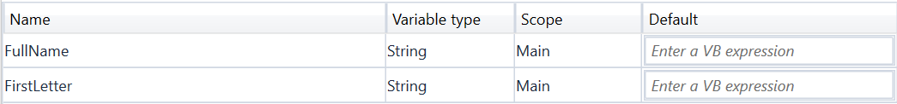

1. Add an [Input Dialog](https://docs.uipath.com/activities/docs/input-dialog) activity to the **Designer** panel.
2. In the **Input Label** field, type "Type your full name please.".
3. In the **Dialog Title** field, type "What is your name?".
4. In the **Value entered** field, add the FullName variable. This variable stores whatever the user writes when prompted with the **Input Dialog** activity.
5. Add an [Assign](https://docs.uipath.com/activities/docs/assign) activity under the **Input Dialog** one.
6. In the **Properties** panel, in the **To** field, add the FirstLetter variable.
7. In the **Value** field, type FullName.Substring(0,1). The FirstLetter variable is assigned the new value created by the FullName.Substring(0,1) expression.

**NOTE:** This field uses the Substring() function to find the first character from the string added by the user in the **Input Dialog**.

1. Add a [Write Line](https://docs.uipath.com/activities/docs/write-line) activity under the **Assign** one.
2. In the **Properties** panel, in the **Text** field, enter the FirstLetter variable. This means that the **Output** panel is going to display the first letter of what the user wrote in the **Input Dialog**. The project should look as in the following screenshot.

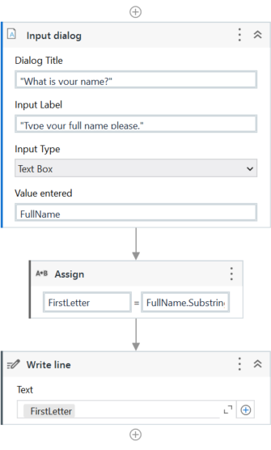

1. Press F5. The **What is your name?** window is displayed.
2. Type your name in the text field and click **OK**. In **UiPath Studio**, in the **Output** panel, note that the first letter of your name is displayed.

